SIMATS ENGINEERING

CO3-ASSESSMENT TOOL 1

COURSE CODE: CSA1606
COURSE NAME: Data Warehousing and Data Mining

NAME: Ajay I
Register no.: 192421147

COURSE OUTCOME COVERED

CO3: Evaluate the effectiveness of classification techniques on real-time data for accurate prediction, enabling informed decision-making. (BL3, BL4, BL5)
Assessment Tool Weightage: 50%

- Relationship Between Age and Photograph Preference

Aim
To determine whether there is a significant relationship between children's age and their preference for photographs using the Chi-square test, and to calculate the covariance and correlation between photograph preferences.

Algorithm
- Enter the given age-group and photograph-preference data.
- Create a contingency table of age groups versus photograph preferences.
- Apply the Chi-square test to test the relationship between age and preference.
- Compare the p-value with the significance level (0.05).
- Use cov() to calculate the covariance between B and C and the covariance matrix.
- Use cor() to calculate the correlation between B and C and the correlation matrix.
- Interpret the results and identify any limitations in the study.
- Stop.
Program:
# Data
A <- c(18, 2, 20)
B <- c(22, 28, 10)
C <- c(20, 40, 40)

# Combine preferences
preferences <- cbind(A, B, C)

# Covariance between B and C
cov(B, C)

# Covariance matrix
cov(preferences)

# Correlation between B and C
cor(B, C)

# Correlation matrix
cor(preferences)

# Chi-square test
data <- matrix(c(18,22,20,
2,28,40,
20,10,40),
nrow = 3,
byrow = TRUE)

chisq.test(data)
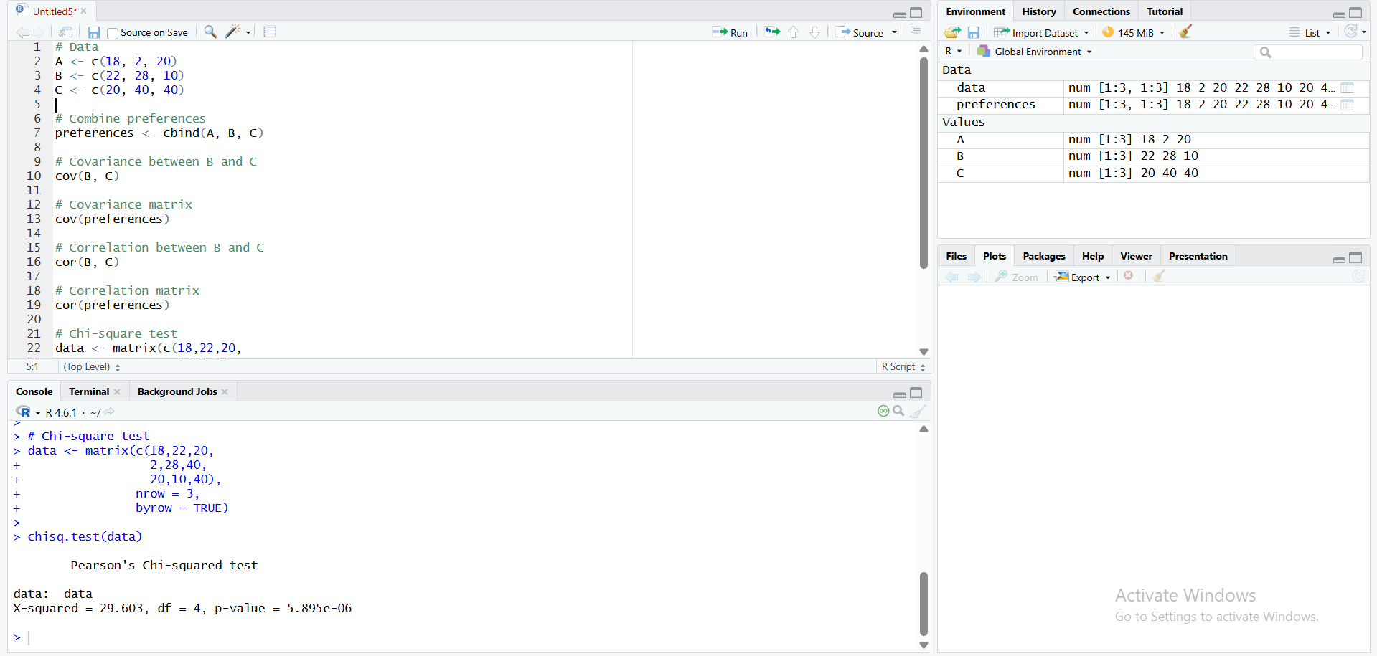

2. Box Plot for Identifying Outliers in Tennis Players' Scores

Aim
To visualize the distribution of points scored by tennis team players using a box plot in R and identify whether any player has an unusually high or low score (outlier).

Algorithm / Steps
- Start
- Create a dataset containing the Player ID, Player Name, and Points Scored.
- Store the points scored by all 15 players in a vector.
- Calculate the five-number summary:
- Create a box plot using the boxplot() function in R.
- Observe the points lying outside the whiskers of the box plot.
- Identify those points as potential outliers.
- Stop.
Program:
player_id <- c("P1", "P2", "P3", "P4", "P5",
"P6", "P7", "P8", "P9", "P10",
"P11", "P12", "P13", "P14", "P15")
player_name <- c("Player A", "Player B", "Player C", "Player D",
"Player E", "Player F", "Player G", "Player H",
"Player I", "Player J", "Player K", "Player L",
"Player M", "Player N", "Player O")
points <- c(12, 15, 14, 10, 18,
20, 22, 13, 11, 35,
16, 17, 19, 21, 23)
players <- data.frame(player_id, player_name, points)
print(players)
print(summary(points))
Q1 <- quantile(points, 0.25)
Q3 <- quantile(points, 0.75)
IQR_value <- IQR(points)
cat("Q1 =", Q1, "\n")
cat("Q3 =", Q3, "\n")
cat("IQR =", IQR_value, "\n")
lower_bound <- Q1 - 1.5 * IQR_value
upper_bound <- Q3 + 1.5 * IQR_value

cat("Lower Bound =", lower_bound, "\n")
cat("Upper Bound =", upper_bound, "\n")
outliers <- players[points < lower_bound | points > upper_bound, ]
cat("\nOutliers:\n")
print(outliers)
boxplot(points,
main = "Box Plot of Points Scored by Tennis Players",
ylab = "Points Scored",
col = "lightblue",
border = "black")
text(x = 1, y = points, labels = player_id, pos = 4,
cex = 0.8)
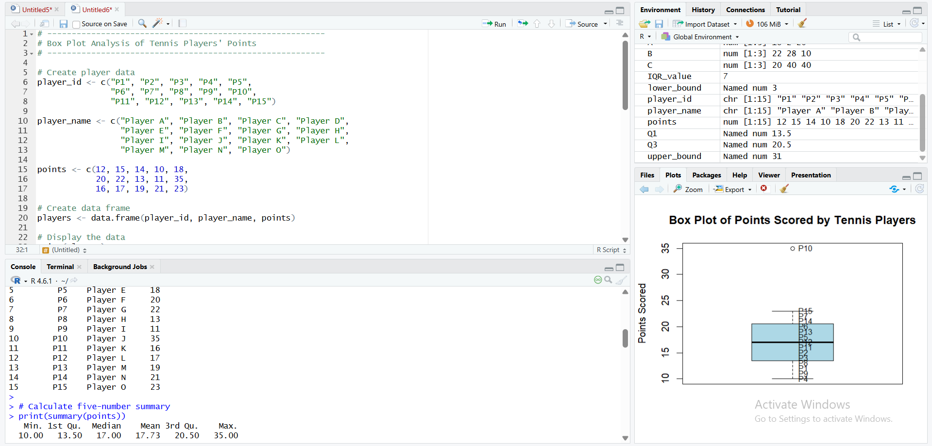

3. Decision Tree Classifier for Loan Approval

Aim
To build a Decision Tree classification model in R using customer attributes such as Age, Income, Employment Status, and Credit Score to predict whether a customer's Loan Approval is Yes or No.
Algorithm

- Start
- Create the historical loan dataset with the attributes:
- Convert the categorical attributes into factors.
- Split the dataset into training and testing data.
- Build a Decision Tree classifier using the training data.
- Visualize the generated decision tree.
- Use the trained model to predict loan approval for the testing data.
- Compare the predicted values with the actual values.
- Calculate the confusion matrix and model accuracy.
- Use the trained decision tree to predict approval for new customers.
- Stop.

Program :

library(rpart)
library(rpart.plot)
data <- data.frame(
Age =
c("young","young","middle","old","old","old","middle","young","young","old","middle","mi
ddle","old","young","middle"),
Income =
c("high","high","high","medium","low","low","low","medium","low","medium","medium","
high","medium","medium","low"),
Employment = c("employed","self-employed","employed","employed","unemployed","self-
employed","unemployed","employed","unemployed","self-employed","employed","self-
employed","unemployed","self-employed","employed"),
Credit =
c("good","average","good","good","poor","average","poor","average","poor","good","average
","good","poor","average","poor"),
Loan =
c("yes","yes","yes","yes","no","no","no","yes","no","yes","yes","yes","no","yes","no")
)
data$Age <- factor(data$Age)
data$Income <- factor(data$Income)
data$Employment <- factor(data$Employment)
data$Credit <- factor(data$Credit)
data$Loan <- factor(data$Loan)
model <- rpart(Loan ~ Age + Income + Employment + Credit,data = data,method =
"class",control = rpart.control(minsplit = 2, cp = 0))
print(model)
rpart.plot(model,main = "Decision Tree for Loan Approval")
predicted <- predict(model, data, type = "class")
cat("\nPredicted Loan Approval:\n")
print(predicted)
cat("\nConfusion Matrix:\n")
print(table(Actual = data$Loan,Predicted = predicted))
accuracy <- mean(predicted == data$Loan)
cat("\nAccuracy:\n")
print(accuracy)
cat("\nAccuracy Percentage:\n")
print(accuracy * 100)

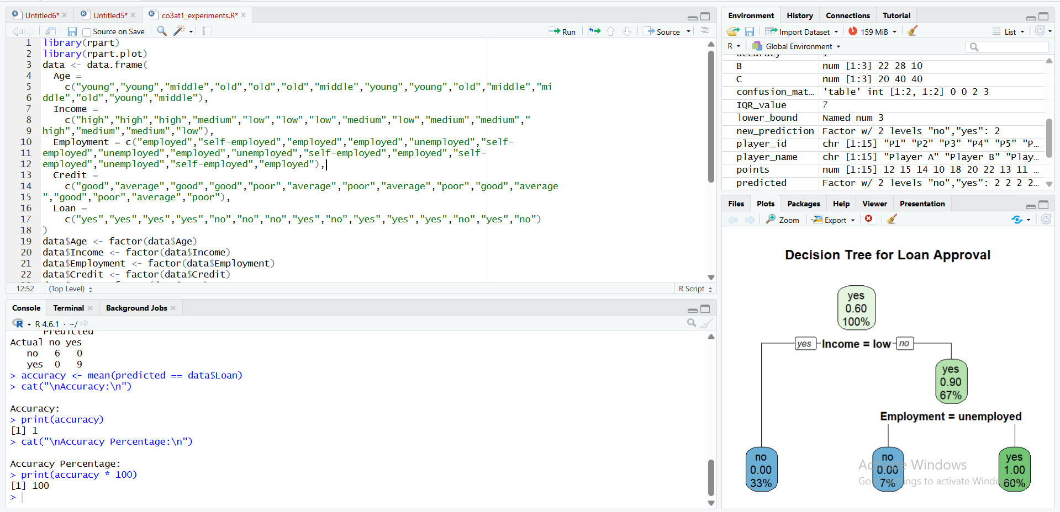

4. Comparison of Year 9 Class Exam Results

Aim

To compare the performance of Class A and Class B using mean, median, and range, and to visualize the distribution of their exam scores using a box plot.
Algorithm

· Enter the exam scores of Class A and Class B.
· Calculate the mean of each class.
· Calculate the median of each class.
· Calculate the range of each class.
· Compare the mean, median, and range of both classes.
· Create a box plot for both classes.
· Observe the median, spread, and possible outliers.
· Interpret which class performed better and which class has greater variation.
· Draw the conclusion.

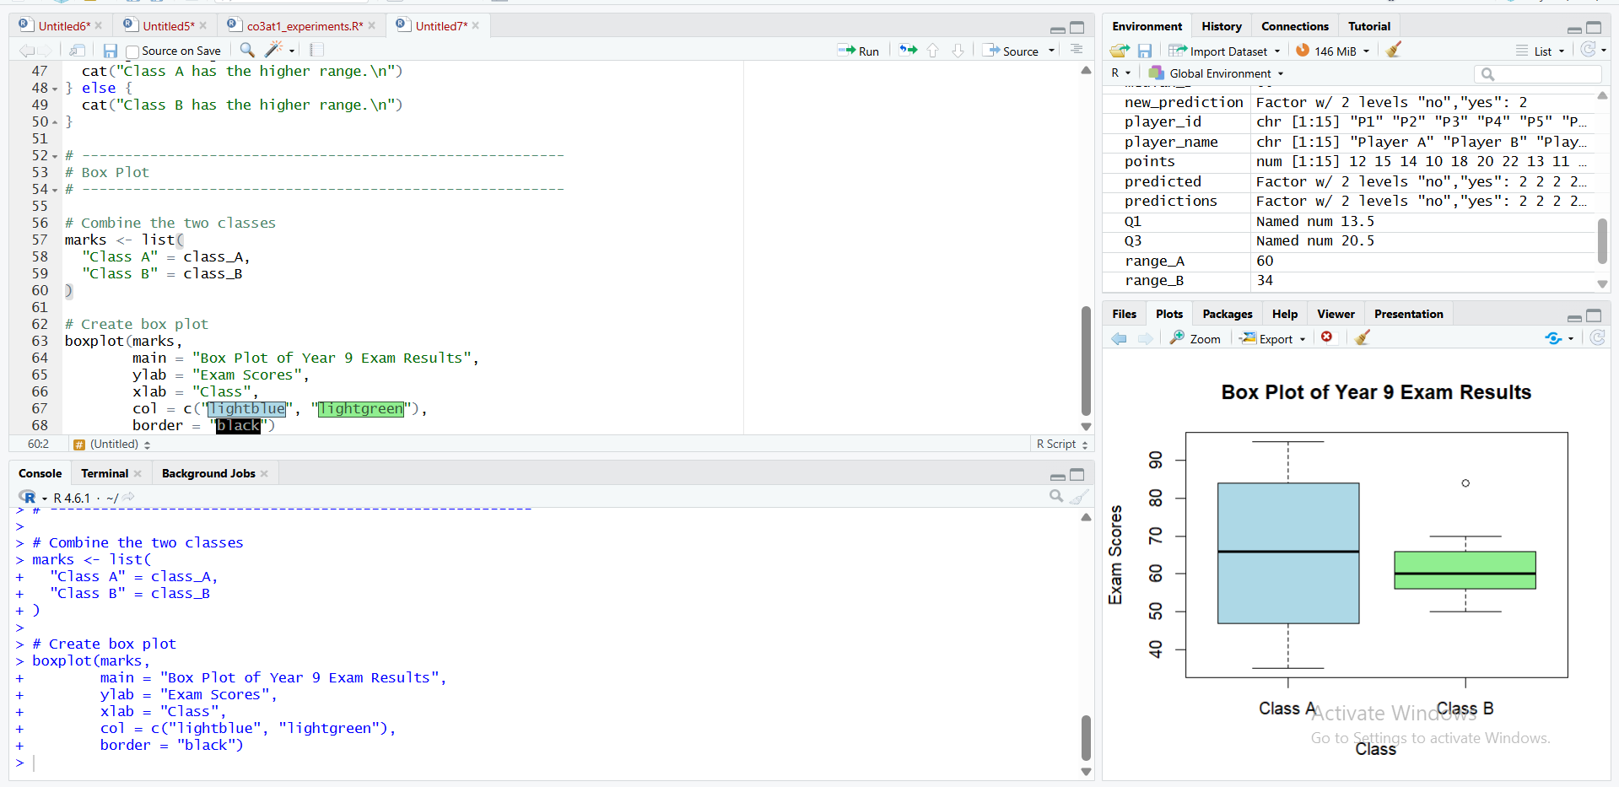

Analysis of Age and Body Fat Data

Aim
To calculate the mean, median, and standard deviation of age and body fat percentage for 18 randomly selected adults, and to visualize the data using boxplots, a scatter plot, and a Q-Q plot in R.
Algorithm
- Enter the age and body fat percentage data of the 18 adults.
- Calculate the mean of age and body fat percentage.
- Calculate the median of age and body fat percentage.
- Calculate the standard deviation of age and body fat percentage.
- Draw separate boxplots for age and body fat percentage.
- Draw a scatter plot with age on the x-axis and body fat percentage on the y-axis.
- Draw Q-Q plots to check whether age and body fat percentage approximately follow a normal distribution.
- Interpret the results.
- Stop.
